QUESTION 1: Find out the mail servers of the following domain :
Ibm.com
Wipro.com

---->STEPS:

step 1:open pen tester VMware workstation
step 2:open command prompt
Step 3: type
ipconfig
nslookup
www.ibm.com
www.wipro.com
--->RESULT:

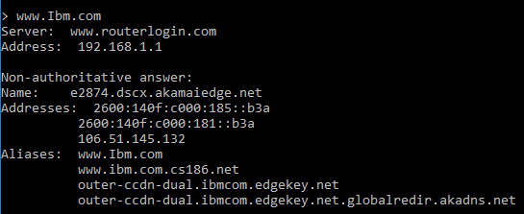
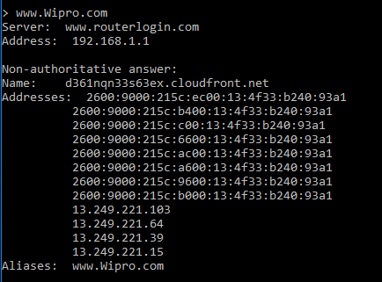

QUESTION 2 : Find the locations, where these email servers are hosted.

FOR IBM.COM----> mail@ibm.com

Mailbox Domain: mx0b-001b2d01.pphosted.com
IP :148.163.158.5
Country :United States
City :Sunnyvale
Latitude :37.424900054932
Longitude :-122.0074005127
ISP :N/A

FOR WIPRO.COM----> mail@wipro.com

Mailbox Domain: wipro-com.mail.protection.outlook.com
IP :104.47.124.36
Country :United States
City :Redmond
Latitude :47.680099487305
Longitude :-122.12059783936
ISP :N/A

QUESTION 3:
Open kali-pc
Right click on the screen and open terminal

Type:
sudo su –
Enter password
Enter – nmap –Pn –sS 203.163.246.23

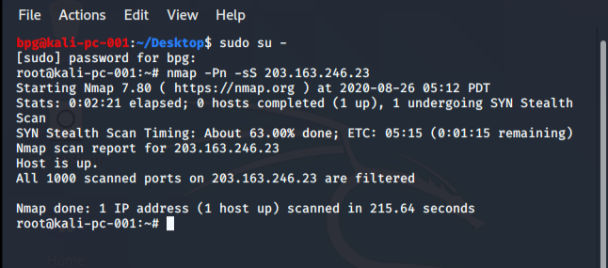

question 4: Install nessus in a VM and scan your laptop/desktop for CVE.
Scanned the laptop and find severity of all applications in my laptop like Critical,high, medium, Info

